

COLLEGE of INFORMATICS and ELECTRONICS

Department of Computer Science
and Information Systems

End-of-Semester Assessment Paper

Academic Year: | 2007/2008 | Semester: | Autumn
Module Title: | Computer Organisation 1 | Module Code: | CS4211
Duration of Exam: | 2½ Hours | Percent of Total Marks: | 80
Lecturer: | Dave Burns | Paper marked out of : | 80

Instructions to Candidates:
Section 1. Answer all Multiple Choice questions: | 10 Multiple Choice Questions on a separate sheet. All questions in Section 1 are compulsory. 2 marks for each question. Circle the answer that you think is appropriate. If you wish to change your answer, cross out the circled answer and circle your new choice.
Section 2. Attempt 3 of the 4 questions.

Section 2 – Attempt 3 questions

Q1.

a. Convert 38.25 to a 32-bit floating point binary representation for a computer. (6 marks)

A 32-bit word computer displays a memory address 0006ce28. How many bytes, and how many words, are in memory between this address and address 008084c? (4 marks)

b. By drawing up a truth table, derive the Sum and Carry for a binary half-adder with inputs A and B.
(6 marks)

Using your results, sketch a logic gate circuit that will give the outputs from the half-adder.
(4 marks)
Section 2 – continued

Q2.
a. Explain how RFID technology works, and briefly describe one active and one passive application. (10 marks)

b. With the aid of a sketch, describe how a hard disk drive works. (4 marks)

What are the factors which effect access speed? Explain how disk technology is designed to minimise access speed. (4 marks)

Give two reasons why Solid State (Flash) memory has not replaced disk memory.

(2 marks)

Q3. Write brief notes on 4 of the following:

Moore’s ‘Law’, and its effects
LAN using Ethernet bus topology
Transformation of a high-level source program to an executable object program
RISC v CISC architecture
The Domain Name System in the Internet
(20 marks)

Q4

a. Using the java code below, describe in detail how the system stack is used to implement the calls to the various methods in the code.

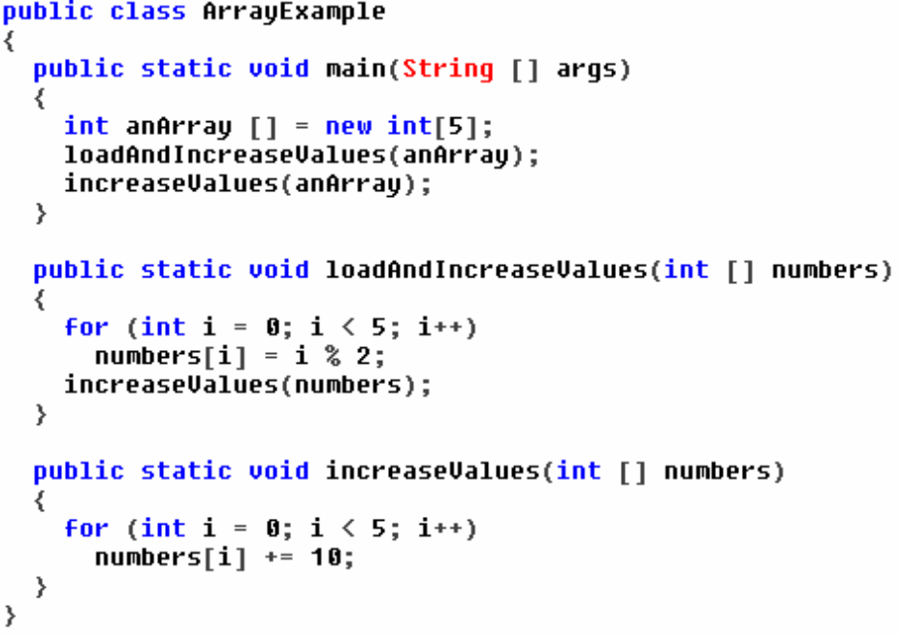

(7 marks)

b. Describe the functions of, and the ‘relationship’ among, the three main types of volatile memory: registers, cache and RAM. (7 marks)

c. Describe either (i) an Intel Pentium Processor or (ii) a Sony Playstation - with regard to such features as registers, ALU, word size, cache memory, multimedia and clock speed. (6 marks)

